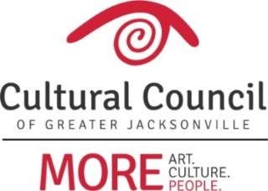

2018-2019 Cultural Service Grant Committee

Penny Thompson - CHAIR

Anne Boccuzzi (board rep)

Mac Bracewell (board rep)

David Faliszek (comm rep)

Mauricio Gonzalez (comm rep)

Sandra Hull-Richardson (comm rep)

Anne Lufrano (comm rep)

Truitte Moreland (comm rep)

Richard Naylor (comm rep)

Ben Rubin (comm rep)

Jannet Walker Ford (board rep)

TBD
Liaison - City Council Representative

TBD
Liaison - Mayor’s Office Representative

