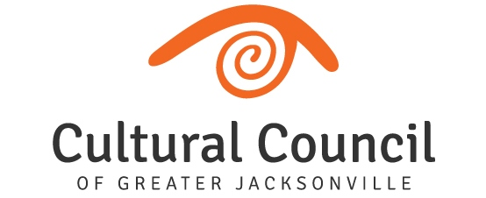

2019-2020 CSGP Compliance Workshop: Wednesday, Dec. 11, 2019, 10 a.m.-noon, @ WJCT

Welcome!
- Introductions and Housekeeping

Misc.
- New CSGP assistant - Megan Reid (appintern@culturalcouncil.org)
- New communications staff- Ellen Cottrill (ellen@culturalcouncil.org)
- New Cultural Service PROGRAM Grants
- 2020-2021 CSGP LOI & Process Timeline
- Contact Info Changes
- CSGP Committee

CSG Compliance
- Foundant
- Ordinance/Contractual Requirements
- Compliance Timeline
- Follow-up Items Review
- Logos
- Compliance Monitoring Visit

Questions?
- Amy Palmer – apalmer@culturalcouncil.org; (904)358-3600 x14
- Megan Reid (appintern@culturalcouncil.org)

