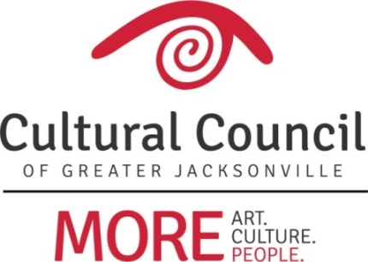

2019-2020 Cultural Service Grant Program On-site Assignments

FUNDING LEVEL ONE
- Cathedral Arts Project Truitte Moreland
- Cummer Museum of Art & Gardens Jannet Walker Ford
- Florida Theatre David Faliszek
- *(The) Jacksonville Children’s Chorus Sandra Hull-Richardson
- Jacksonville Symphony Association Anne Boccuzzi
- Museum of Contemporary Art - Jacksonville David Faliszek
- Museum of Science & History Ben Rubin
- WJCT Public Broadcasting Richard Naylor
FUNDING LEVEL TWO
- Beaches Museum Jannet Walker Ford
- (The) Florida Ballet Ellen Williams
- Friday Musicale David Faliszek
- Jacksonville Historical Society Kyle Enriquez
- Players by the Sea Ben Rubin
- Ritz Chamber Players Sandra Hull-Richardson
- Theatre Jacksonville Jannet Walker Ford
- Theatreworks Ellen Williams
FUNDING LEVEL THREE
- All Beaches Experimental Theatre Kyle Enriquez
- *(The) Art Center Cooperative Ben Rubin
- *Beaches Fine Arts Series Sandra Hull-Richardson
- Civic Orchestra of Jacksonville Diana Donovan
- Don’t Miss A Beat Anne Boccuzzi
- Hope at Hand Truitte Moreland
- Jacksonville Dance Theatre Kyle Enriquez
- Mandarin Museum & Historical Society Ellen Williams
- Riverside Fine Arts Association Richard Naylor
- Springfield Preservation & Revitalization Council Diana Donovan
- (The) Performer’s Academy Richard Naylor

*Change in Level

2019-2020 Cultural Service Grant Program On-site Assignments

Anne Boccuzzi
Don’t Miss A Beat
Jacksonville Symphony Association

Diana Donovan
Civic Orchestra of Jacksonville
Springfield Preservation & Revitalization Council

Kyle Enriquez
All Beaches Experimental Theatre
Jacksonville Dance Theatre
Jacksonville Historical Society

David Faliszek (Back-up Volunteer)
Florida Theatre
Friday Musicale
Museum of Contemporary Art - Jacksonville

Jannet Walker Ford
Beaches Museum
Cummer Museum of Art and Gardens
Theatre Jacksonville

Sandra Hull-Richardson
(The) Jacksonville Children’s Chorus
Beaches Fine Art Series
Ritz Chamber Players

Truitte Moreland
Cathedral Arts Project
Hope at Hand

Richard Naylor
(The) Performer’s Academy
Riverside Fine Arts Association
WJCT

Ben Rubin
(The) Art Center Cooperative
Museum of Science and History
Players by the Sea

Ellen Williams
(The) Florida Ballet
Mandarin Museum & Historical Society
Theatreworks

