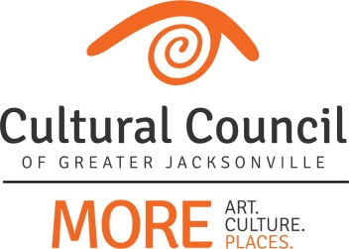

ART IN PUBLIC PLACES COMMITTEE
Meeting Agenda REVISED
November 9, 2016 12pm
Cultural Council Conference Room
Times Union Center for the Performing Arts
300 W. Water St. Ste. 201, Jacksonville, FL 32202

Invitees: David Engdahl, Wesley Gibbon, Mary Harvey, Lea Mahan, Christina Parrish, Sandra Hull Richardson, JaMario Stills, Nominees: Tracie Thornton; Mico Fuentes, Suzanne Pickett, Cory Driscoll
Invited Guests: CCGJ Staff
------------------------------------------------------------------------------------------------------------------------------------------

- Call to Order – Dave

ACTION ITEMS
- Items to consider approval of:
  - October meeting minutes
  - DIA – ASP recommendations

OLD BUSINESS

- APPC nominations
- Project updates
  - 11-9-2016 APP Committee Project Report
    - DIA Urban Arts Project Christina/Mason
    - Haskell Downtown Sculpture Initiative Dave
    - Winton Drive Artwork Project Tracie/Christie
- APP Ordinance
  - Proposed changes
- ASP Roles & Responsibilities

IMPORTANT DATES:
Every Single Artist Lounge: November 10, 2016, 5-6:30pm (The Volstead)
Next APPC meeting: December 14, 2016, 12-1:30pm (CCGJ Conference Room)

PUBLIC COMMENT

Adjournment

