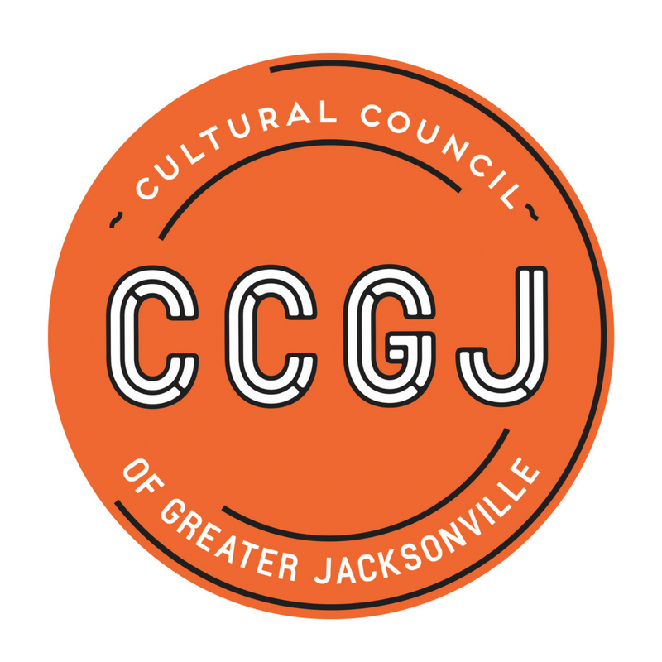
Enrich life in Northeast Florida by investing in Arts and Culture
Board of Directors Meeting
November 26, 2018
Times Union Center for the Performing Arts
300 Water Street, Jacksonville, FL 32202
Cultural Council Conference Room

Board Members Present
Ann Carey (Chair), JaMario Stills, Kemal Gasper, Diana Donovan, Dave Engdahl, Claudia Baker (call-in), Pamela Smith, Mac Bracewell, Jackie Cornelius, Bill Ferry, Janet Walker Ford

Board Members Absent
Charlie Joseph, Anne Bocuzzi

Staff Present
Chelsey Cain, Amy Palmer, Christie Holechek, Cedric Lewis, Ashley Sedghi-Khoi, Jihan Grant

City Council Liaison
Council Member John Crescimbeni

Call to Order
Ms. Ann Carey, Chair, called the meeting to order at 12:05 p.m.

Consent Agenda
There were no questions or edits regarding the consent agenda.

UPON MOTION duly made, seconded and carried, the consent agenda was approved. The consent agenda included the following: Board Meeting Minutes 10/18/18.

Committees
Selection Committee
Ms. Carey reviewed the search process from succession planning through the search and screening of candidates and in-person interviews. It was the unanimous decision of the Selection Committee to recommend Ms. Joy Young to the Board of Directors as the agency’s next executive director.
Discussion followed regarding Ms. Young’s qualifications and competencies as perceived by the Selection Committee and Staff. Questions regarding her knowledge of the agency’s recent struggles were addressed and committee members expressed confidence in Ms. Young’s abilities to lead the agency. Public comment was made: Mr. Darren Dailey of the Jacksonville Children’s Chorus said that he would work for Joy and Mr. Numa Saisselin, Florida Theater and Search Committee member, concurred. Potential start date would be February 5, 2019.

UPON MOTION duly made, seconded and carried, the Cultural Council of Greater Jacksonville Board of Directors approved Joy Young as the next executive director.

Ms. Carey was tasked with finalizing terms with Ms. Young and providing the offer letter. The recommendation was made to prepare the communications plan for the press; Ms. Carey took that on as a task. In addition, Ms. Carey stated that the Transition Team will be reconstituted to meet over the next eight weeks to develop the onboarding section of the succession plan in preparation of Ms. Young’s arrival.

Finance Committee
Mr. Cedric Lewis, Finance Director, shared that he reconciled the APP DIA Phase 2 project finances per the request of the board in its October meeting. This reconciliation yielded no change to the FY19 budget that was reviewed in detail in the October Board meeting and was ready for Board approval.
Discussion took place about the importance of the Board’s participation in fund raising for the Arts Awards this year where the budget requires a net of $150,000 from the event to cover agency operating expenses. The “Green Sheet” was reviewed with the board that tracks the budget and actuals of the Arts Awards; it was recommended to adjust the sheet to reflect the dates/tasks of the updated project plan.

UPON MOTION duly made, seconded and carried, the Cultural Council of Greater Jacksonville approved the FY19 Cultural Council budget.

Art in Public Places
Ms. Christie Holechek, Art and Public Places Director, gave an overview of Art and Public Places. She reviewed the FY19 Annual Plan of projects, based on milestones, to be completed this next year. There was brief discussion around planning for a Public Art Master Plan; Ms. Carey expressed the desire for the agency to focus on project work with development of procedures and practices that will allow us to deliver on our commitments. A Master Plan can come later.
Ms. Holechek also reviewed how UNF interns participate in the APP program; Ms. Diana Donovan asked if JU students could also be involved and noted that she can help connect JU students to the agency.
Ms. Jannet Walker-Ford requested the Board receive regular APP project updates; Ms. Holechek committed to creating a green/yellow/red dashboard to track the status of each project with respect to budget, timeline, resources and that the dashboard will tie in with the monthly financial reports.
Ms. Holecheck presented the agency’s newly developed Gift Policy for art gifted to the City from a private donor. The policy states that APP staff reviews the requested gift and makes a recommendation; the Cultural Council Board of Directors reviews and acts upon that recommendation; the decision is then provided to the Mayor’s office.
A question was asked about the role and responsibilities of the APP Committee beyond “acting on the recommendation of the Arts Selection Panel”; Ms. Holecheck committed to documenting the role and sharing it with the Board.

UPON MOTION duly made, seconded and carried, the Cultural Council of Greater Jacksonville adopted the Art in Public Places Gift Policy.

Old Business
Statewide Advocacy Report
Ms. Amy Palmer, Director of Grants Administration, reported that total state funding in the past two years dropped from $43M to $2M, resulting in a cut from $150K to $10K in the Cultural Council budget. The Cultural Council is participating in statewide advocacy efforts and the Board can help with these efforts, specifically if any Board members have a connection to Duval Delegation elected officials. Ms. Palmer will be attending a meeting on December 10, 2018 with the delegation to represent the Cultural Council; Mr. John Crescimbeni will provide a contact from City Hall for the Duval Delegation.

Board of Directors Meeting Monthly Dates
The Board agreed to meet monthly through July of 2019; meeting dates were distributed.

Board Dues
Mr. Lewis will send invoices to all Board Members for 2019 dues ($1,000) and will include a link for online payment.

CSG Mixer
Ms. Palmer reminded everyone that the CSG Appreciation Mixer was scheduled for Thursday, November 29, 2018 at 4:30pm in the Cultural Council’s office and the Board was encouraged to attend.

Public Comment
The floor was opened for public comment.

Closing
The meeting was adjourned at 1:34 p.m.

