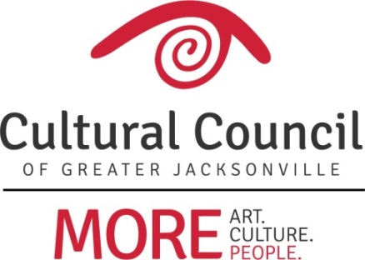

Cultural Service Grant Program (CSGP) Report – April 19, 2018

2018-2019 CSGP Letter of Intent
The deadline for organizations to submit a Letter of Intent (LOI) to the 2018-2019 Cultural Service Grant Program was February 27. The Letter of Intent is a gauge of applicant eligibility. If an applicant isn’t eligible for CSGP, then making that determination prior to the submission of a full application saves the organization much time and effort.

Twenty-nine organizations submitted LOIs – all 26 of the currently-funded Cultural Service Grantees and three new applicants. One of these was found to be eligible for CSGP according to the eligibility criterion contained within the ordinance:
- (The) Art Center Cooperative

Two organizations are not currently eligible:
- Deck the Chairs
  - Primary mission is not arts/cultural
- (The) Eartha M. M. White Historical Museum
  - Insufficient revenues to support match for minimum request amount

CSGP Committee:
The three nominees to the CSGP Committee (Dave Faliszek, Jannet Walker Ford, and Anne Lufrano) are currently making their way through the City approval process.

The CSGP Committee orientation will take place May 17.

