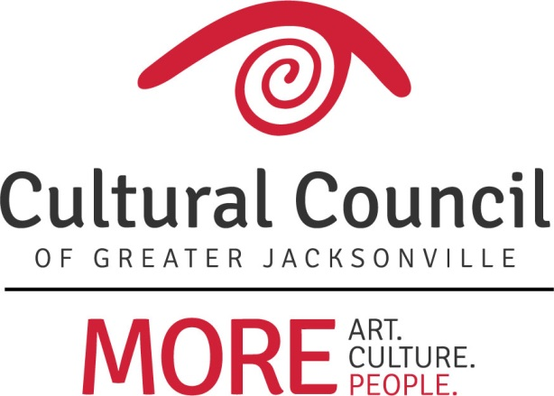

CSGP Committee Report
December 14, 2017

CSGP Committee
There are three vacancies to fill on the CSGP Committee for 2018-2019: one board representative and two community representatives. Many thanks to Ann Carey, Frank Watson and Beth Harvey, who have completed their service on the committee.

2017-2018 CSGP
As of December 5, the Cultural Council’s contract with the city was still pending.

2018-2019
Deadline for the Letter of Intent (LOI) form for the 2018-2019 Cultural Service Grant Program is Feb. 27, 2018. The form will open in early January, and may be accessed through the Cultural Council’s website. The deadline will be publically noticed and promoted with a press release and through the e-newsletter. The Letter of Intent is the first step in the CSGP application process. Its purpose is to:

- signal an organization's intention to apply to CSGP
- determine eligibility for applicant organizations
- gather essential information and documentation
- inform the Cultural Council of Greater Jacksonville's request for funding to the City of Jacksonville for the Cultural Service Grant Program.

CCGJ Board Demographic Surveys
As part of its commitment to cultural equity, the Cultural Council tracks the progress of Cultural Service Grantees in relation to the diversity of its board and staff members. As the grantmaker, the Cultural Council also tracks its own progress. To this end, CCGJ board members will be asked to complete the attached survey.

