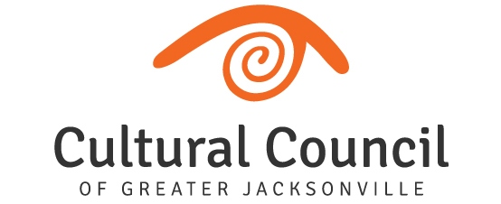

GRANT PROGRAMS REPORT – March 5, 2020

Cultural Service Grant Program
- Action Needed – Florida Theatre/Theatreworks Jacksonville Merger
Two Cultural Service Grantees -- Florida Theatre and Theatreworks Jacksonville – have merged. Theatreworks’ educational programming will continue under the Florida Theatre, which has long been the venue for Theatreworks shows. The merger adds a long desired educational component to Florida Theatre programming and will relieve Theatreworks of its operational and fundraising duties.

Theatreworks operated normally for the first quarter of the grant period, but the merger became official in late December. Following consultation with Florida Theatre and Theatreworks and city staff, Cultural Council staff recommended to the CSGP Committee at its Feb. 12, 2020 meeting that the remainder of Theatreworks’ 2019-2020 grant award be reallocated to Florida Theatre. The Theatreworks programming objectives would continue to be the same as presented in its grant application and would be monitored throughout the grant period. As originally intended, grant expenditures would continue to go to Theatreworks staff, who are now employed by the Florida Theatre. Present at the CSGP Committee meeting were Numa Saisselin, president of Florida Theatre, and Jamie Kent, formerly Theatreworks Executive Director and now Theatreworks Program Manager, to explain the merger and answer questions, as well as, John Snyder with the city’s grants and compliance office, who spoke to the approval of the city for the approach to the merger and of a plan of action for administering the affected Cultural Service Grants.

The CSGP Committee unanimously approved a motion to recommend to the Cultural Council Board of Directors that the remainder of Theatreworks’ 2019-2020 Cultural Service Grant award be reallocated to the Florida Theatre, providing for the continuation of Theatreworks’ program objectives and expenditures. Staff seeks approval by the board for the CSGP Committee’s recommendation.

- 2020-2021 CSGP Letter of Intent to Apply
  - Deadline: March 4, 2020

- Pilot - Cultural Service PROGRAM Grant
Twelve organizations applied for the 2019-2020 Cultural Service PROGRAM Grant, but only six met the eligibility criteria as defined in the CSGP ordinance. The CSGP Committee is currently reviewing the grant applications and will hold hearings beginning at 9 a.m., Wednesday, April 1 in the Davis Gallery of the Times-Union Center for the Performing Arts. The committee will make award recommendations and also recommend how to allocate any unused funds ($25,000 was originally set aside for the pilot program). The Cultural Council Board of Directors will then consider these recommendations at its April 16 meeting.
- Cultural Council Founder Focus of MOCA Exhibition
Cultural Council board members are encouraged to visit the new exhibition at MOCA Jax – “Breaking Boundaries: The Vision of Jacqueline B. Holmes,” which runs through Aug. 2. Holmes was one of the founders of the Arts Assembly, now the Cultural Council of Greater Jacksonville, and was also instrumental in the formation of Jacksonville’s Art in Public Places Program.
For more info:
https://mocajacksonville.unf.edu/Exhibitions/Featured/Breaking-Boundaries--The-Vision-of-Jacqueline-Holmes/
https://www.bizjournals.com/jacksonville/news/2020/02/11/moca-honors-jacksonville-entrepreneur-in-newest.html
- CSGP Committee
  - Please see Governance Committee Report

