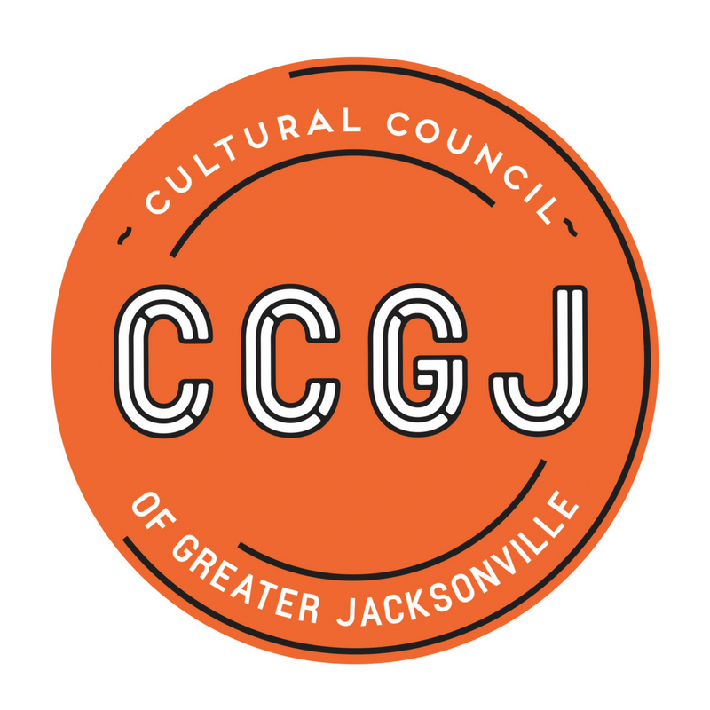
Development Committee Meeting
August 28, 2018
10:00 A.M.
Times Union Center of the Performing Arts
300 Water Street, Jacksonville, FL 32202
Present:
Members- Kemal Gasper & Pam Smith
Staff- Chelsey Cain, Tony Allegretti, Cedric Lewis (Call in)

Call to Order 10:03 A.M.

- Mr. Allegretti, Executive Director, opened the conversation with the history of the Cultural Council of Greater Jacksonville’s funding revenues. He put emphasis on the cuts in state funding.
- There was discussion on who is leading development; the agency’s Board of Director’s or CCGJ staff. Ms. Smith discussed how this is a big strategic question that needs to answered by the Board and the new Executive Director.
- Mr. Lewis, Finance Director, proposed the fundraising goal for the next fiscal year (FY 2018-2019) is $156,000. These funds will support the agency’s basic operations.
- There was conversation on the difference between advocacy and development.
- Mr. Gasper discussed the idea of advancing advocacy. He suggested the following: Board Members writing “Thank You” notes to City Council Members and Board Members attending City Council meetings.
- Action: The Development Committee will define clear expectations for fundraising and advocacy.
- Mr. Gasper, mention the possibility of hiring a Development Consultant. Staff and Ms. Smith were open to this idea.
- Finally, there was discussion on defining what fundraising events the Cultural Council wants to undertake year to year.
Adjourned 10:58 A.M.

