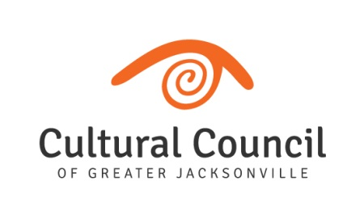
Executive Director’s Report – May 2019
Major Program Reports
Director of Public Art Report
Grants Administration Report
Artist and Community Service Report

Resource Development and Fundraising
LEAP – Planning continues for this 4-day event. Milestones include:
- Secured location for Arts Awards
- Developed process for selecting award winners
- Finalized sponsorship package
- Raised approximately $15K of $200K toward LEAP

External Relationships
Presented to Downtown Chamber of Commerce about CCGJ as LAA (Local Arts Agency)
Presented to Downtown Vision, Inc. about CCGJ as LAA and Public Art Projects
Presented to Leadership Jacksonville about CCGJ as LAA, Public Art Projects, and potential of arts for positive community impacts.
Presented to Flagler College Arts Administration Minor class. Discussed role of LAA, careers, and importance of arts advocacy.
Presented to Black Knight
Participated in United Way’s Cocktails and Conversations
Completed Leadership Jacksonville New Leaders Summit
Met with leaders of the following organizations: MOSH, MOCA, Main Library, FemArt, Teco Energy, WJCT, Jewish Family & Community Service, Don’t Miss a Beat, Art Republic.
Interviewed with Melissa Ross on WJCT.
Met with Council Member Guilliford.
Coordinated Advocacy work for Florida DCA on behalf of Northeast Florida arts and cultural organizations. Team representing three CSG’s along with CCGJ staff developed a plan for regional advocacy. CCGJ distributed over 75 messages to regional state representatives and staffers; created a social media campaign; and submitted source material for TU editorial and op-ed.
DCA Funding History:
- FY 2014-15 $43,073,117
- FY 2018-19 $2,650,000
- FY 2019-20 $21,250,028 (Governor Ron DeSantis has not signed off on FY 2019-20 funding yet)
Serving as internship site for Florida State University. Hosting Student Lilly Mauti, graduate student.
Highlights
Met with Mayor Curry, Sam Mousa, and Brian Hughes
Awarded cultural Internship program for up to 90 Duval County 16 to 21-year-old students
Serving on Art Ventures Panel for Community Foundation
Hosting a grant workshop in partnership with NEA, NEH, Florida DCA, and Georgia Council for the Arts
Continuing to meet with individual board members.

