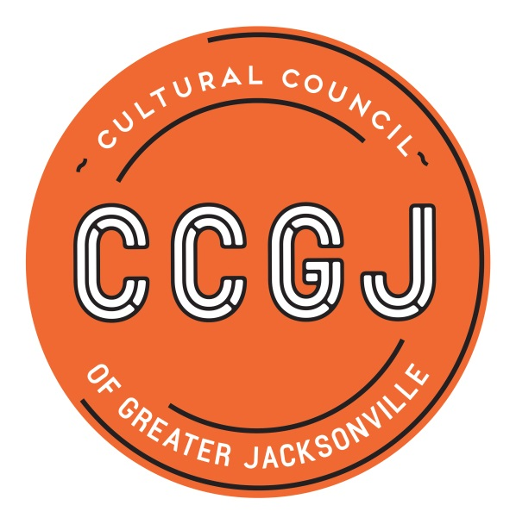

CSGP Pre-read for February 21, 2019 CCGJ BOD Meeting

2019-2020 CSGP LOI
The application process for the Cultural Service Grant Program (CSGP) begins with a Letter of Intent to Apply, or LOI. For organizations not currently funded through CSGP, completing the Letter of Intent (LOI) is a mandatory prerequisite to completing the full application for the 2019-2020 Cultural Service Grant Program. Currently-funded organizations must complete an abbreviated version of the LOI to ensure that they have maintained eligibility for CSGP for 2019-2020.

The purpose of the LOI is to:
- Signal the organization's intention to apply to CSGP
- Determine eligibility for applicant organizations
- Gather essential information and documentation
- Inform the Cultural Council of Greater Jacksonville's request for funding to the City of Jacksonville for the Cultural Service Grant Program.

The deadline for the LOI for the 2019-2020 CSGP process will be Tuesday, March 5, 2019. The online LOI form will be available through the Cultural Council’s website and promoted through a press release, public notice, the Cultural Council’s e-newsletter, and targeted emails to current grantees and prospective applicants.

2019-2020 Cultural Service Grant Program – CSGP Committee process timeline

EVENT | DATES & DEADLINES | TIME | LOCATION
*Meeting:  CSGP orientation | Wednesday, June 12, 2019 | 9-11 a.m. | Cultural Council 300 Water St., Ste. 201, Jax
Deadline: declaration of recusals (based on LOIs) | Monday, June 17, 2019 | COB | **Contact Amy Palmer
*Meeting:  on-sites | Tuesday, July 9, 2019 | 9-11 a.m. | Cultural Council
*Meeting: application review | Thursday, July 25, 2019 | 9-11 a.m. | Cultural Council
Deadline:  on-site reports | Monday, August 26, 2019 | COB | online
Deadline: preliminary scores | Monday, Sept. 9, 2019 | COB | online
*Meeting:  Hearing prep | Wednesday, Sept. 11, 2019 | 9-11 a.m. | Cultural Council
Jax City Council Votes to Approve City Budget (includes CSGP allocation) | Tuesday, Sept. 24, 2019 | 5 p.m. | City Council Chamber, City Hall, 117 W. Duval St., Jax 32202
Hearings | Wednesday, Sept. 25 & Thursday, Sept. 26, 2019 | (arrive: 8:45 a.m.)  9 a.m.-5 p.m. | Davis Gallery, Times-Union Center for Performing Arts 300 Water St., Jax
Cultural Council Board of Directors meeting:  approval of CSGP awards | Thursday, Oct. 17, 2019 | Noon - 2 p.m. | Lynwood Roberts Room, Jax City Hall  117 W. Duval St.  Jax
Grant Process Survey | October/November 2019 | N/A | online
CSGP Appreciation Mixer | Thursday, Dec. 5, 2019 | 4:30-6 p.m. | Cultural Council
*Committee meetings are scheduled for two hours. The first hour is intended for all members; the second hour will focus on training for new members.
**Director of Grants Administration Amy Palmer (apalmer@culturalcouncil.org; (904) 358-3600 x14). Alternate Contact: CSGP Program Coordinator Chelsey Cain (chelsey@culturalcouncil.org; (904) 358-3600 x19)
REQUIRED CITY OF JACKSONVILLE ETHICS TRAINING
Each member of the CSGP Committee is required to take City of Jacksonville Ethics Training at least once during his/her term – preferably during the first year of service.
Bi-monthly Ethics Training for City of Jax Boards and Commissions is offered every other month in the Lynwood Roberts Room, City Hall, First Floor, from noon to 1 p.m. on the following dates:
- Thursday, Feb. 28, 2019
- Thursday, April 25, 2019
- Thursday, June 27, 2019
- Thursday, August 22, 2019 (tentative)
- Thursday, Oct. 24, 2019 (tentative)
- Thursday, Dec. 5, 2019 (tentative)
Please RSVP by sending an email to Lourdes Barboza, Executive Assistant of the Office of Ethics, Compliance and Oversight at lbarboza@coj.net; (904-630-4734). Also, please confirm your attendance at one of the sessions with Chelsey Cain (Chelsey@culturalcouncil.org; (904) 358-3600 x19).
Please arrive 5-10 minutes prior to the start time in order to check in and receive credit for the training.
Pursuant to the American with Disabilities Act, accommodations for persons with disabilities are available upon request. Please allow 1-2 business days notification to process; last minute requests will be accepted, but may not be possible to fulfill. Please contact Disabled Services Division at: V(904) 630-4940, TTY-(904) 630-4933, or email your request to ADAAccommodationRequest@coj.net.

2019-2020 Cultural Service Grant Program – CSGP Process Timeline for Organizations

EVENT | DEADLINES & DATES | TIME | LOCATION
Letter of Intent | Tuesday, March 5, 2019 | 11:59 p.m. | Online
Cultural Equity Commitment one-on-one meetings with CCGJ E.D. | March/April 2019 | TBD | Cultural Council  300 Water St., Ste. 201, Jax 32202
Eligibility Notification | April 2019 | N/A | N/A
Application Workshop | Wednesday, April 17, 2019 | 10 a.m.-noon | WJCT  100 Festival Park Ave.  Jax 32202
Full Application | Tuesday, June 18, 2019 | 11:59 p.m. | Online
On-site Visit from member of CSGP Committee | July/August 2019 - applicant to schedule with assigned reviewer | TBD - applicant to schedule with assigned reviewer | At applicant’s facility/office
Jax City Council Votes to Approve City Budget (includes CSGP allocation) | Tuesday, Sept. 24, 2019 | 5 p.m. | City Council Chamber, City Hall, 117 W. Duval St., Jax 32202
Hearings | Wednesday, Sept. 25 (LEVEL THREE) & Thursday, Sept. 26, 2019 (LEVELS ONE & TWO) | 9 a.m.-5 p.m. | Davis Gallery, Times-Union Center for the Performing Arts (TUCPA)  300 Water St.  Jax 32202
Cultural Council Board of Directors meeting -  approval of CSGP awards | Thursday, Oct. 17, 2019 | Noon-2 p.m. | Lynwood Roberts Room, Jacksonville City Hall,  117 W. Duval St.  Jax 32202
Grant Process Survey | October/November 2019 | N/A | Online
CSGP Appreciation Mixer | Thursday, Dec. 5, 2019 | 4:30-6 p.m. | Cultural Council
Grantee Compliance Workshop | Wednesday, Dec. 11, 2019 | 10 a.m. - noon | WJCT
Grant Period | Oct. 1, 2019-Sept. 30, 2020 | N/A | N/A

