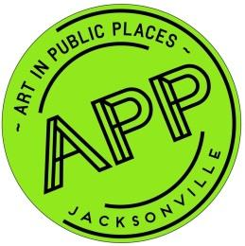
ART IN PUBLIC PLACES REPORT
CULTURAL COUNCIL BOARD OF DIRECTORS MEETING
MARCH 21, 2019
Neighborhood Public Art Projects
- Art in Public Places Art Selection Panels met to select artists for the three Neighborhoods Public Art projects. Finalists have been identified for Winton Drive Project, Legends Community Center Project and Cuba Hunter Park Project. Contract negotiations are underway to commission the artists to design proposals for the three public art projects.
DIA Urban Arts Project Phase II
- A new, alternate artist has been commissioned to design a proposal for 2-D surface art for Phase II to replace artist whose final design was not approved by the Art Selection Panel. The alternate artist is expected to maintain the projected performance schedule for Phase II.
Water Street Parking Garage
- The Water Street Parking Garage Art Selection Panelists approved Haddad-Drugan as the winning final artist team to commission to design a final proposal for review by the Art Selection Panel. Contract negotiations are underway.
EverGreene Architectural Arts Conservation Project
- The contract with the Conservation firm to treat 24 city-owned artworks and memorials was approved by CSPEC and City Council approval for budget appropriation is needed for the conservation work on a portion of the City’s fine arts collection. The budget appropriation will be reviewed on March 29, 2019.
APP Staff
- Christie Holechek, Director of Art in Public Places, resigned from the Cultural Council effective March 1, 2019. Mason Martin, formerly Art in Public Places Project Manager, will serve as the Interim Art in Public Places Senior Project Manager until the Executive Director has filled the Art in Public Places Director position.

- Ashley Sedghi-Khoi, APP Program Coordinator, has a new name, which is Ashley Wolfe.

