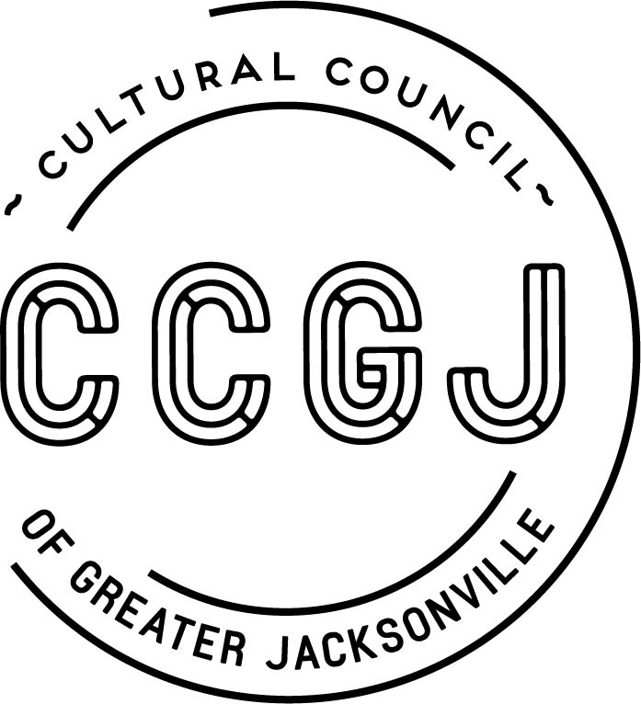

PUBLIC NOTICE

THE CULTURAL COUNCIL BOARD OF DIRECTORS WILL HOLD A MEETING TO DISCUSS CULTURAL COUNCIL BUSINESS.

Friday, August 24, 2018
11:30 AM
Times Union Center for the Performing Arts – Shircliff Lounge
300 Water St.
Jacksonville, FL 32202

For more information contact the Cultural Council: (904) 358-3600

Pursuant to the American with Disabilities Act, accommodations for persons with disabilities are available upon request. Please allow 1-2 business days notification to process; last minute requests will be accepted, but may not be possible to fulfill. Please contact Disabled Services Division at: V(904) 630-4940, TTY-(904) 630-4933, or email your request to ADAAccommodationRequest@coj.net.

