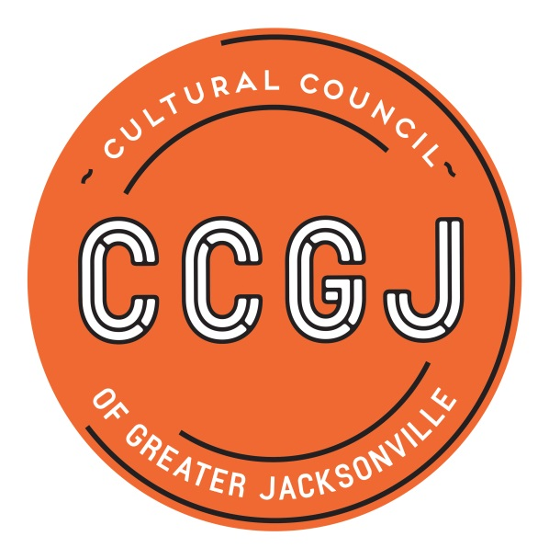

2019-2020 Cultural Service Grant Program – CSGP Committee process timeline

EVENT | DATES & DEADLINES | TIME | LOCATION
*Meeting:  CSGP orientation | Wednesday, June 12, 2019 | 9-11 a.m. | Cultural Council 300 Water St., Ste. 201, Jax
Deadline: declaration of recusals (based on LOIs) | Monday, June 17, 2019 | COB | **Contact Amy Palmer
*Meeting:  on-sites | Tuesday, July 9, 2019 | 9-11 a.m. | Cultural Council
*Meeting: application review | Thursday, July 25, 2019 | 9-11 a.m. | Cultural Council
Deadline:  on-site reports | Monday, August 26, 2019 | COB | online
Deadline: preliminary scores | Monday, Sept. 9, 2019 | COB | online
*Meeting:  Hearing prep | Wednesday, Sept. 11, 2019 | 9-11 a.m. | Cultural Council
Jax City Council Votes to Approve City Budget (includes CSGP allocation) | Tuesday, Sept. 24, 2019 | 5 p.m. | City Council Chamber, City Hall, 117 W. Duval St., Jax 32202
Hearings | Wednesday, Sept. 25 & Thursday, Sept. 26, 2019 | (arrive: 8:45 a.m.)  9 a.m.-5 p.m. | Davis Gallery, Times-Union Center for Performing Arts 300 Water St., Jax
Cultural Council Board of Directors meeting:  approval of CSGP awards | Thursday, Oct. 17, 2019 | Noon - 2 p.m. | Lynwood Roberts Room, Jax City Hall  117 W. Duval St.  Jax
Grant Process Survey | October/November 2019 | N/A | online
CSGP Appreciation Mixer | Thursday, Dec. 5, 2019 | 4:30-6 p.m. | Cultural Council
*Committee meetings are scheduled for two hours. The first hour is intended for all members; the second hour will focus on training for new members.
**Director of Grants Administration Amy Palmer (apalmer@culturalcouncil.org; (904) 358-3600 x14). Alternate Contact: CSGP Program Coordinator Chelsey Cain (chelsey@culturalcouncil.org; (904) 358-3600 x19)
REQUIRED CITY OF JACKSONVILLE ETHICS TRAINING
Each member of the CSGP Committee is required to take City of Jacksonville Ethics Training at least once during his/her term – preferably during the first year of service.
Bi-monthly Ethics Training for City of Jax Boards and Commissions is offered every other month in the Lynwood Roberts Room, City Hall, First Floor, from noon to 1 p.m. on the following dates:
- Thursday, Feb. 28, 2019
- Thursday, April 25, 2019
- Thursday, June 27, 2019
- Thursday, August 22, 2019
- Thursday, Oct. 24, 2019
- Thursday, Dec. 5, 2019
Please RSVP by sending an email to Lourdes Barboza, Executive Assistant of the Office of Ethics, Compliance and Oversight at lbarboza@coj.net; (904-630-4734). Also, please confirm your attendance at one of the sessions with Chelsey Cain (Chelsey@culturalcouncil.org; (904) 358-3600 x19).
Please arrive 5-10 minutes prior to the start time in order to check in and receive credit for the training.
Pursuant to the American with Disabilities Act, accommodations for persons with disabilities are available upon request. Please allow 1-2 business days notification to process; last minute requests will be accepted, but may not be possible to fulfill. Please contact Disabled Services Division at: V(904) 630-4940, TTY-(904) 630-4933, or email your request to ADAAccommodationRequest@coj.net.

