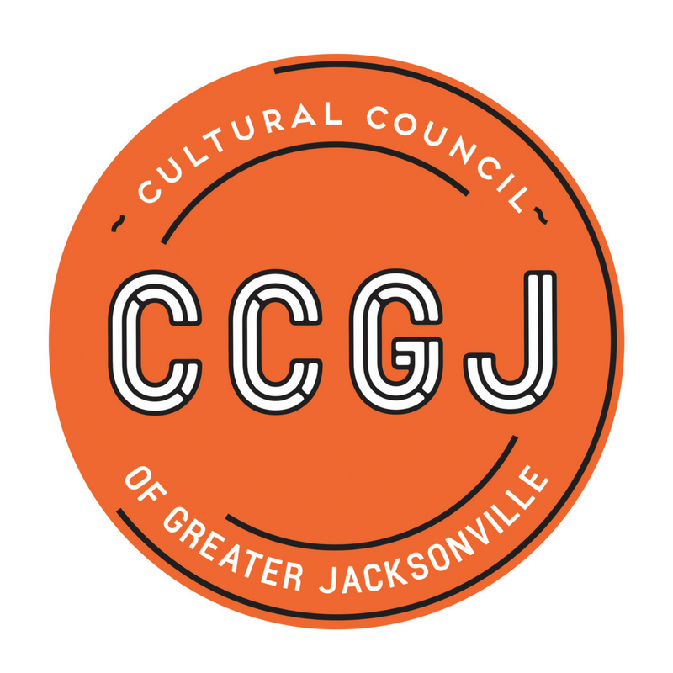
Cultural Council of Greater Jacksonville
Transition Team Minutes
August 16, 2018, 2:00pm
Jacksonville City Hall
117 W. Duval Street, Jacksonville, FL 32202
Don Davis Room

Present

Board Members: Ann Carey, Bill Ferry, Claudia Baker, Dave Engdahl

Discussion
Ms. Ann Carey, Transition Team Lead, called the meeting to order at 2:05 p.m.
With Tony Allegretti’s announcement at the Board meeting that his last day was the end of September, the team increased the prioritization for an interim Executive Director search. The Succession Planning document was reviewed regarding use of an interim and discussion ensued regarding possible candidates.
Action
Ms. Claudia Baker will contact the Nonprofit Center for recommendations from their Nonprofit Center Program.
Public Comment
No public comments.
Adjournment
The meeting was adjourned at 3:15pm.

